MONGO DB- AGGREGATION ASSIGNMENT

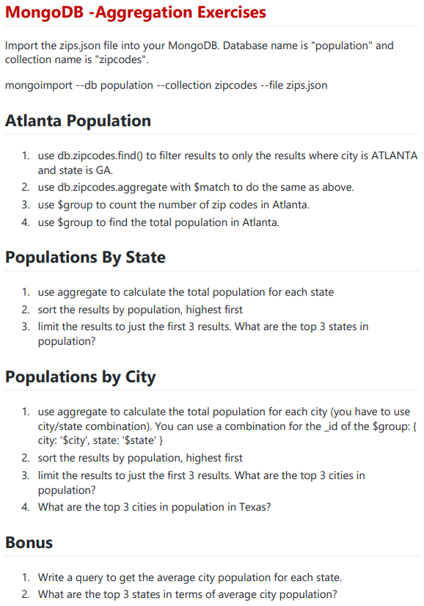

SOLUTIONS: (USING MONGODB COMPASS)

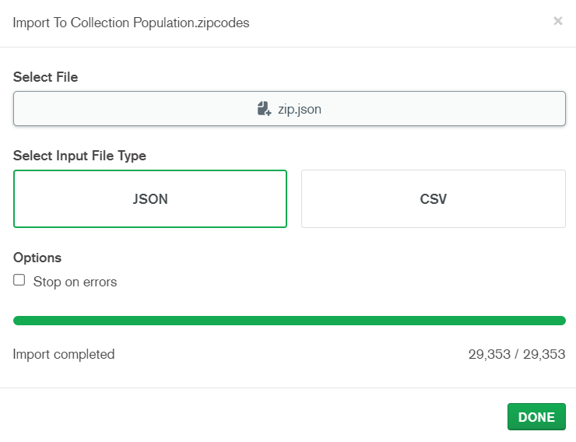

ATLANTA POPULATION:

1.

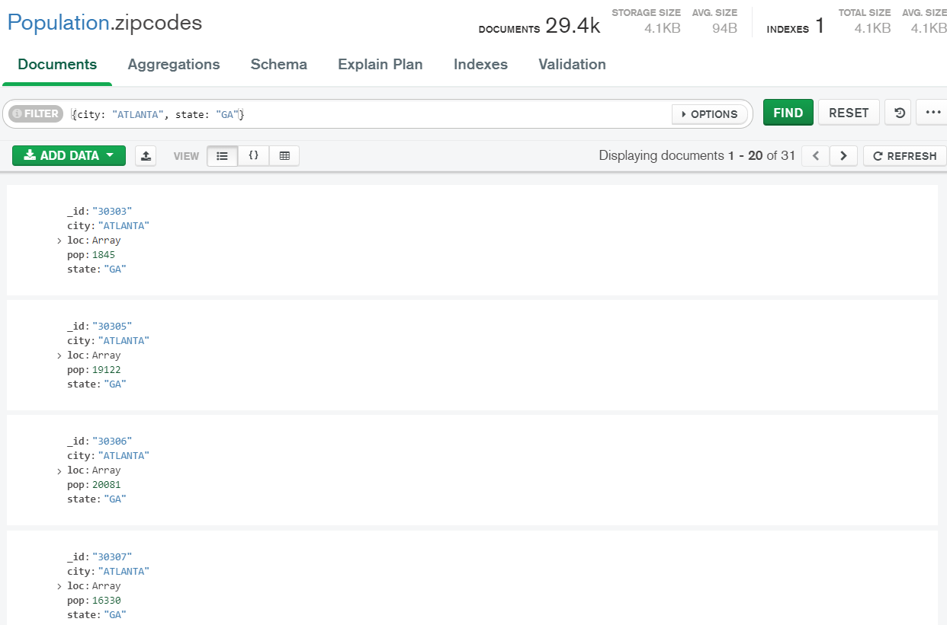

2.

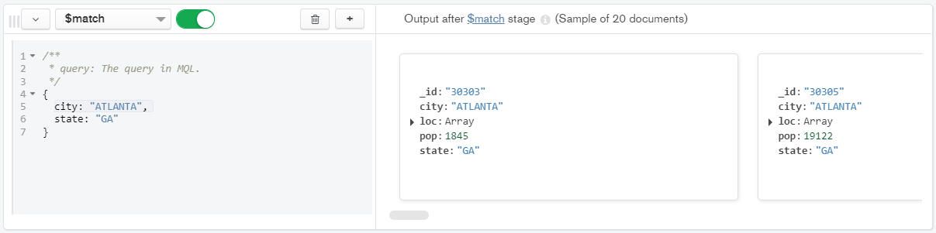

3.

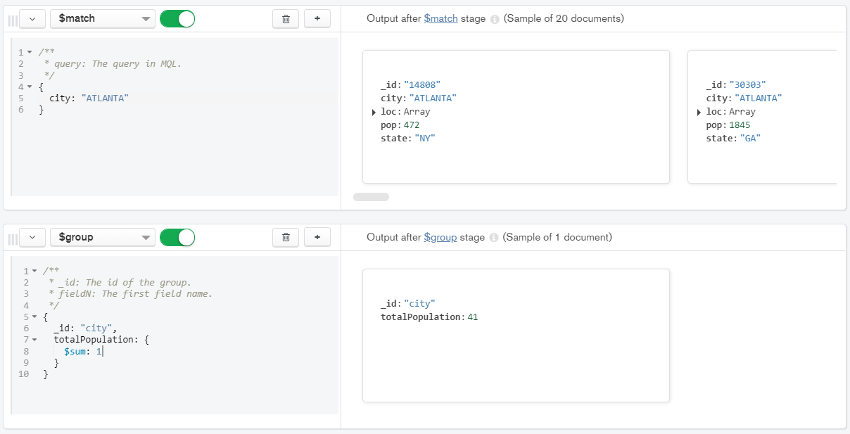

4.

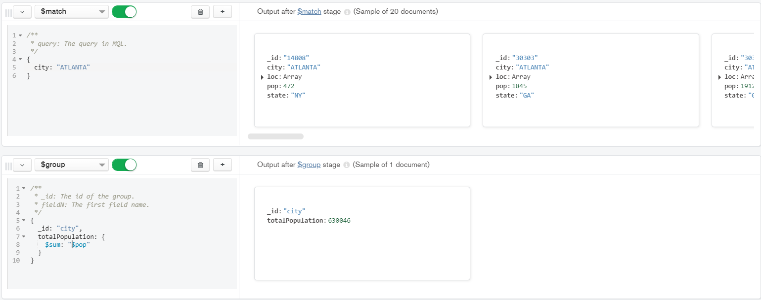

POPULATIONS BY STATE:

1.

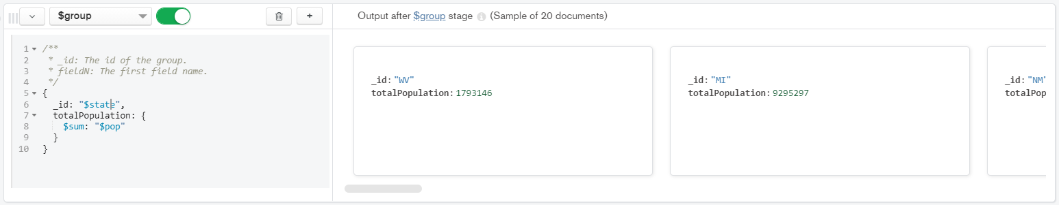

2.

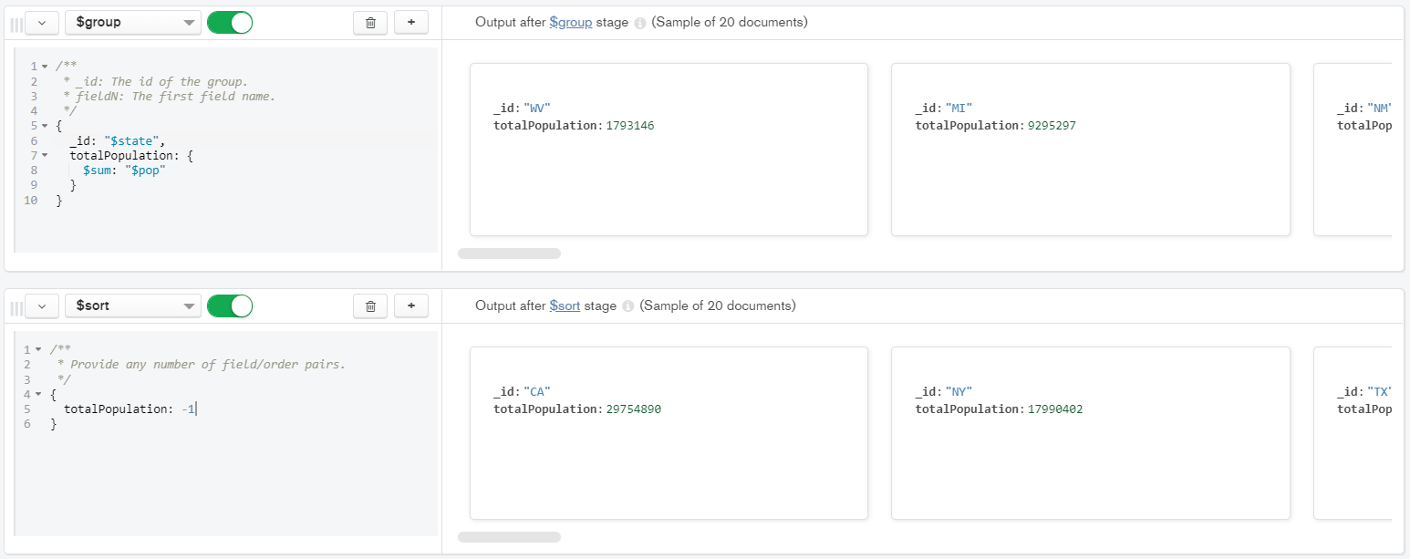

3.

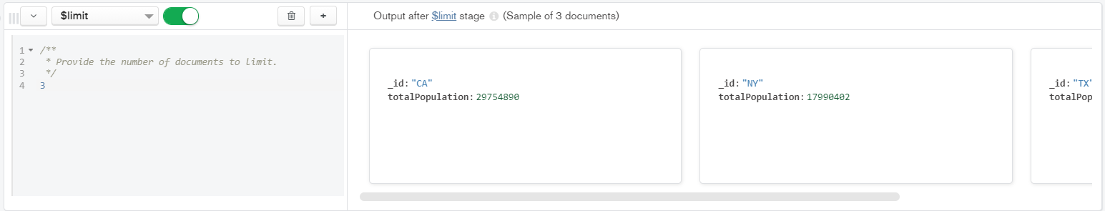

POPULATION BY CITY:

1.

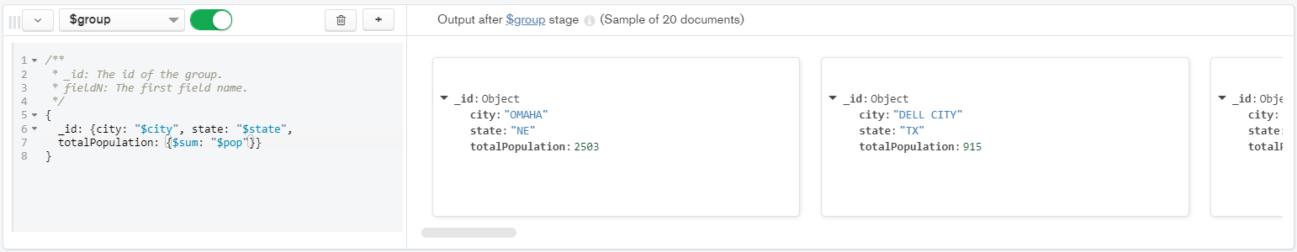

2.

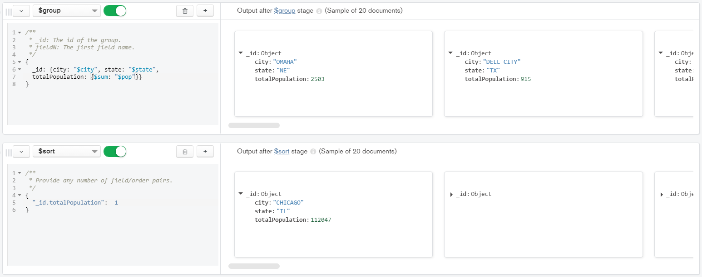

3.

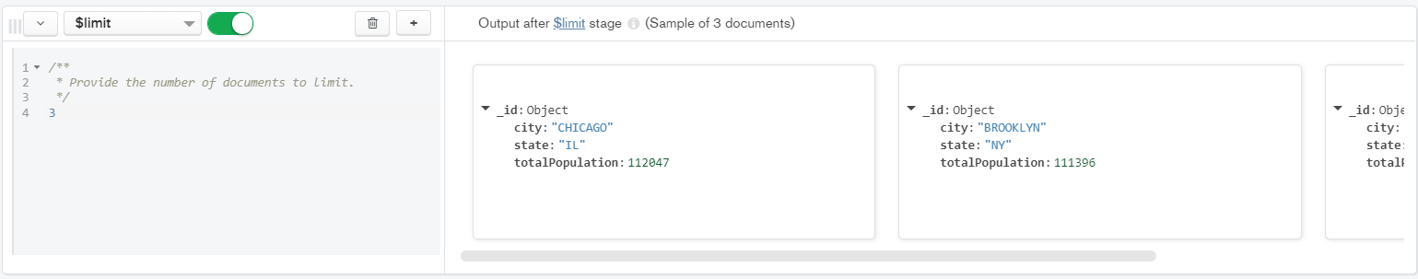

4.

